**STOCK PRICE PREDICTION USING LSTM MODEL AND REGRESSION**

The project includes a LSTM model which uses regression to predict the trend of closing

price of a particular stock.

It has an accuracy of 92% and consists of a sequential model which was trained to predict the

101st day value of the closing price by judging the previous 100 days value.

We have used the module yfinance to work with real time stock data instead of pandas,

keras and tensorflow for model building, matplotlib for graphs, sklearn for scaling the data,

numpy and StreamLit to create and host out Web App.

MADE BY-

PRIYANSH GARG(CS 49)

ANURAG KUMAR(CS 49)

DAKSH MALIK(CS 49)

**TABLE OF CONTENTS:**

|  |  |  |
| --- | --- | --- |
| **Sr. No** | **DESCRIPTION** | **PAGE. No** |
| 1. | Theme/Intro of Project | 3 |
| 2. | My Contribution | 3 |
| 3. | Results | 3 |
| 4. | Conclusion | 3 |
| 5. | Literature Survey | 4 |
| 6. | Background and Preliminaries |  |
| 7. | Proposed Approach |  |
| 8. | Conclusion and future work |  |

**INTRODUCTION:**

Prediction of the Stock Market is a challenging task in predicting the stock prices in the

future. Due to the ﬂuctuating nature of the stock, the stock market is too difﬁcult to predict.

Stock prices are constantly changing every day.

Applying all extracted rules at any time is a major challenge to estimate the future stock

price with high accuracy.

The latest prediction techniques adopted for the stock market such as Artiﬁcial Neural

Network, Neuro-Fuzzy System, Time Series Linear Models (TSLM), Recurrent Neural

Network (RNN).

We have used a new approach which is Long Short Term Memory(LSTM) for predicting the

trend..

**MY CONTRIBUTION:**

* Importing the datasets using YAHOO! FINANCE.
* Scaling of data using min max scaler.
* Calculating the mean of 100th and 200th days of closing stock price.

**RESULTS:**

The model is successfully able to predict the closing price trend of any stock given that its stock ticker is entered correctly.

It also gives us a graphical representation of how the closing price has been varied over the last 100 days, 200 days and an overall estimation.

**CONCLUSION:**

The model successfully uses the LSTM and regression to predict the stock trends.

**LITERATURE SURVEY:**

We have applied attention-based LSTM neural based networks for stock trend prediction

COMPARATIVE ANALYSIS:

|  |  |  |  |  |
| --- | --- | --- | --- | --- |
| **S.No** | **Techniques** | **Advantages** | **Disadvantages** | **Parameter used** |
| 1. | Artificial Neural Network | Lower Prediction error | Prediction gets worse with increase in noise | Stock Closing Price |
| 2. | Support Vector Machine | Does not lose much accuracy when applied to a outside sample | Less predictive ability in case of minor fluctuations | Consumer investment,net revenue, net income |
| 3. | Hidden Markov Model | Used for optimization purpose | Decoding and learning | Technical indicators |
| 4. | ARIMA | Robust and efficient | Suitable for short term predictions | Open, high, low, closing prices |
| 5. | Time Series Linear Model | Integrate the actual data to the ideal linear model | Traditional and Seasonal trends are present in the data | Data and number of months. |
| 6. | RNN | Previous time points to input layer contains input | Possible to feed words through a much smaller set of nodes | Input hidden and output layers |
| 7. | LSTM(Regression | Best for trend prediction | It is prone to overfitting and cannot work properly if there are data errors. | Stock Closing Price |

The only difference between the Regression model and the ANN Model is that the ANN gives us a more precise and accurate prediction of the Closing price value whereas Regression is more capable of predicting the Trends.

**BACKGROUND AND PRELIMINARIES:**

**PROPOSED APPROACH/FRAMEWORK:**

This Project is predicting stocks for all companies listed on the site- finance.yahoo.com with an accuracy of 92% using LSTM Networks.

We have developed the code in following steps:

1. We have developed the python fileStock_Trend_Prediction.ipynb which is used to fetch stock data of companies from Yahoo Download API.
2. Then We have written a data keras_model.h5 file which contains classes and functions to download data, normalise and process data, feature selection, simple sequence, multi sequence, draw the graph for predictions etc.
3. The last step was to create a WebApp using StreamLit for which we created an app.py file and hosted it on our local network.

The main purpose of using LSTM was to explore this type of Recurrent Neural Network (RNN) and the use of regression which is best suited for trend predictions.

We have used live data for stocks which means that the model considers the data from the start (when the stock came) till the last day of stock market.

**FLOWCHART FOR STOCK TREND PREDICTION MODEL**

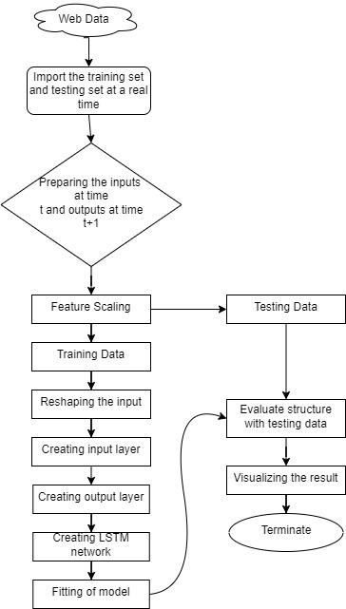

**RESULTS AND DISCUSSION:**

**Dataset used:**

For the stock market trend prediction the dataset has been derived using the module finance in python which picks the data from the site known as finance.yahoo.com which consists of almost all the stocks.

We have used finance instead of Pandas module so as to enable our model to use real-time data , and simulate the result in real time. This means that the data used by finance is from the beginning, that is, the point where the stock came into existence till the last day on which the stock market was open.

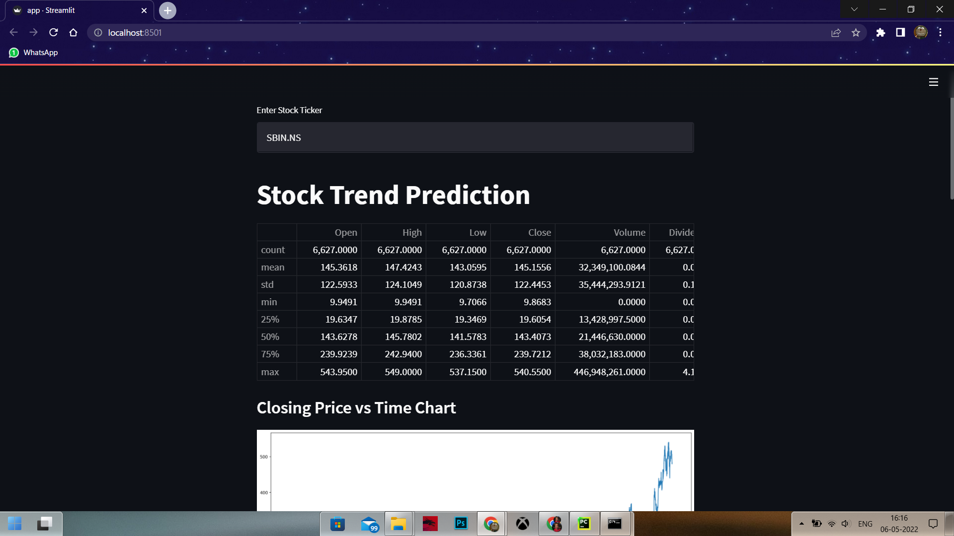

This is the raw data for the stock State Bank Of India(SBI), stock ticker of SBIN.NS.

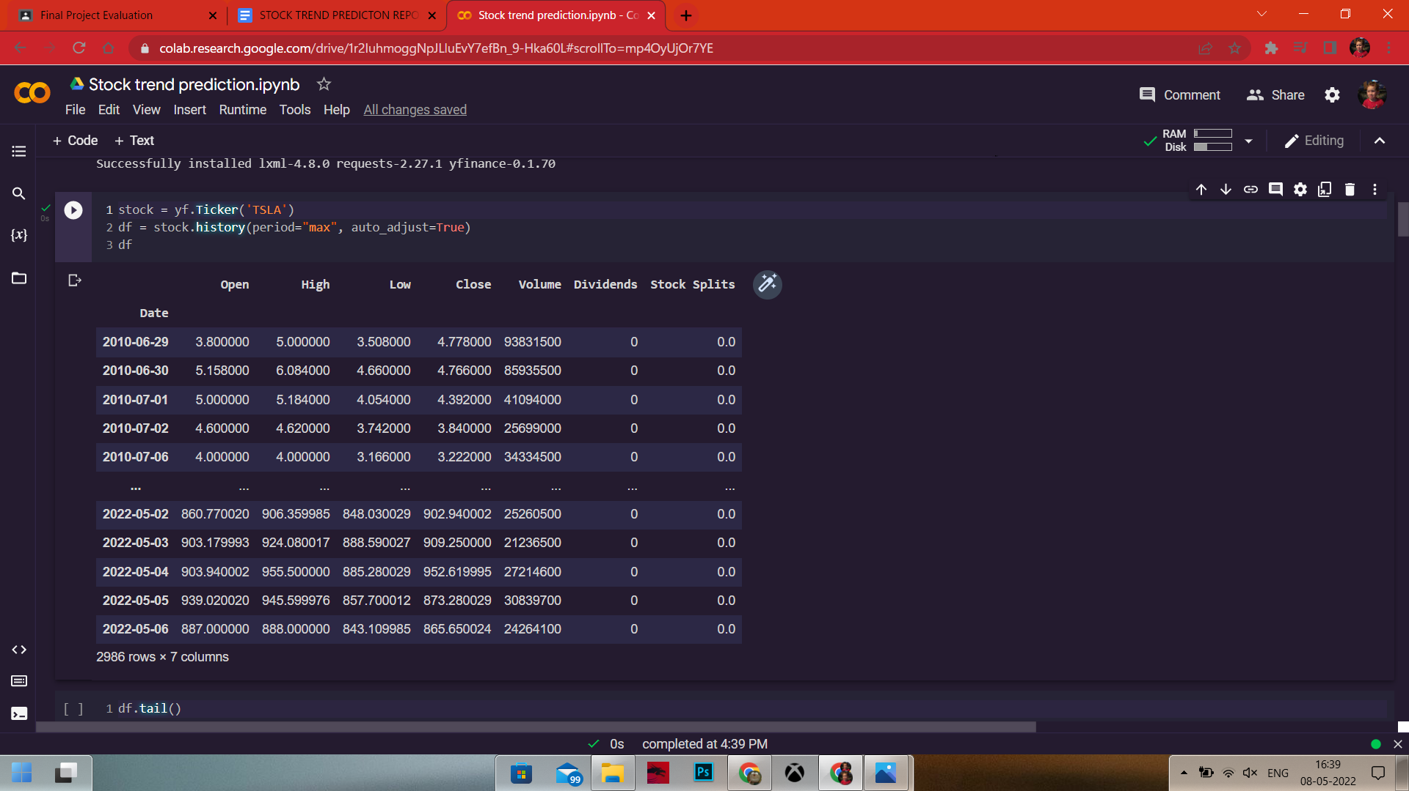

Here you can see the code behind the importing of the dataset.

Above image represents the stock details for the Tesla stock.

**Implementation details-**

After importing the dataset from finance we have scaled the data according to our model requirements then we have trained the model by dividing the data into training and testing parts. We have divided the data into 70% training and 30% testing..

With the help of keras module we have imported the dense dropout and sequential model by the use of which the model has been trained.

The training of the model is divided into 4 layers and then combined by using the dense layer feature.

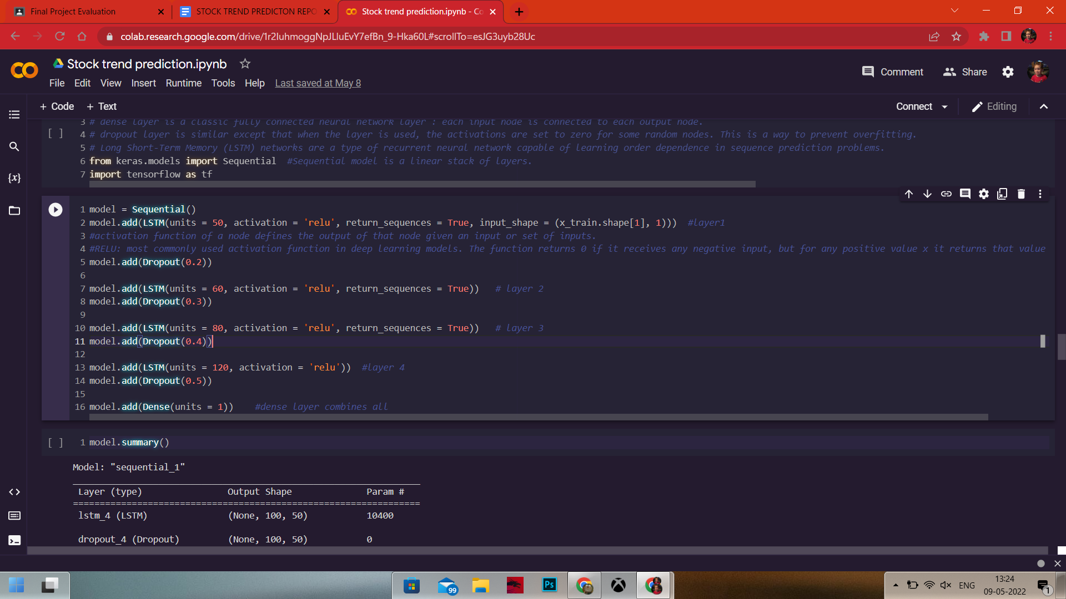

The image shows how the model has been trained using the keras module with the help of dense layer, dropout and sequential features

The model has been further combined using the gradient Adam.

Initially we have used epochs of 150.

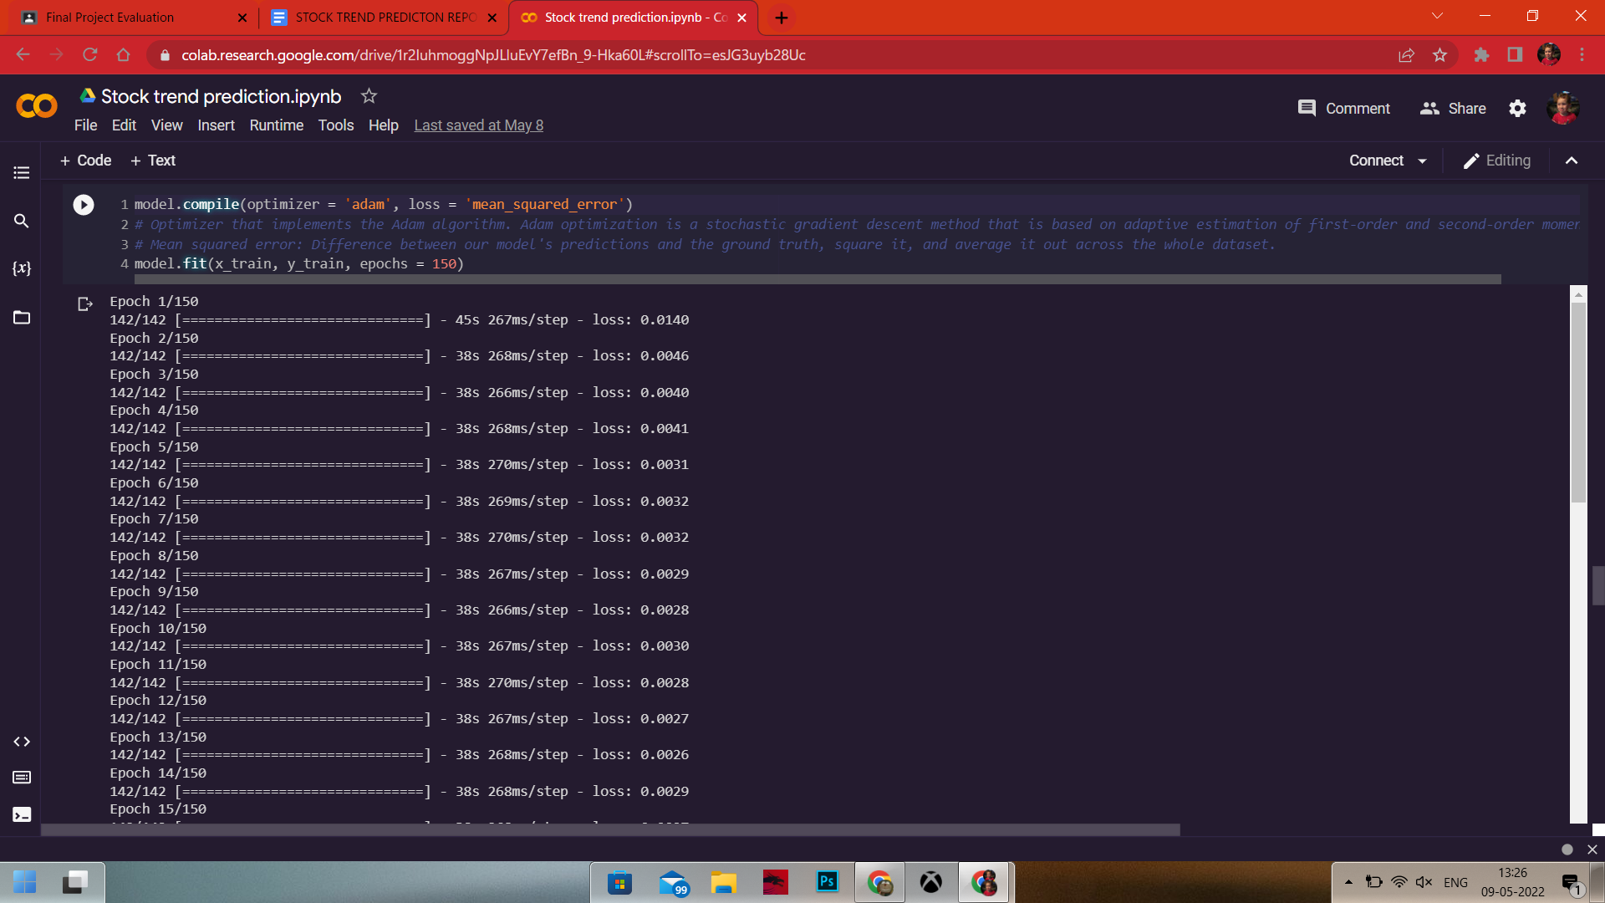

The above image shows how the model has been combined.

After which we have calculated the values for the past 100 days aggregate and 200 days aggregate to predict the values for the 101th day and similarly for 201th day.

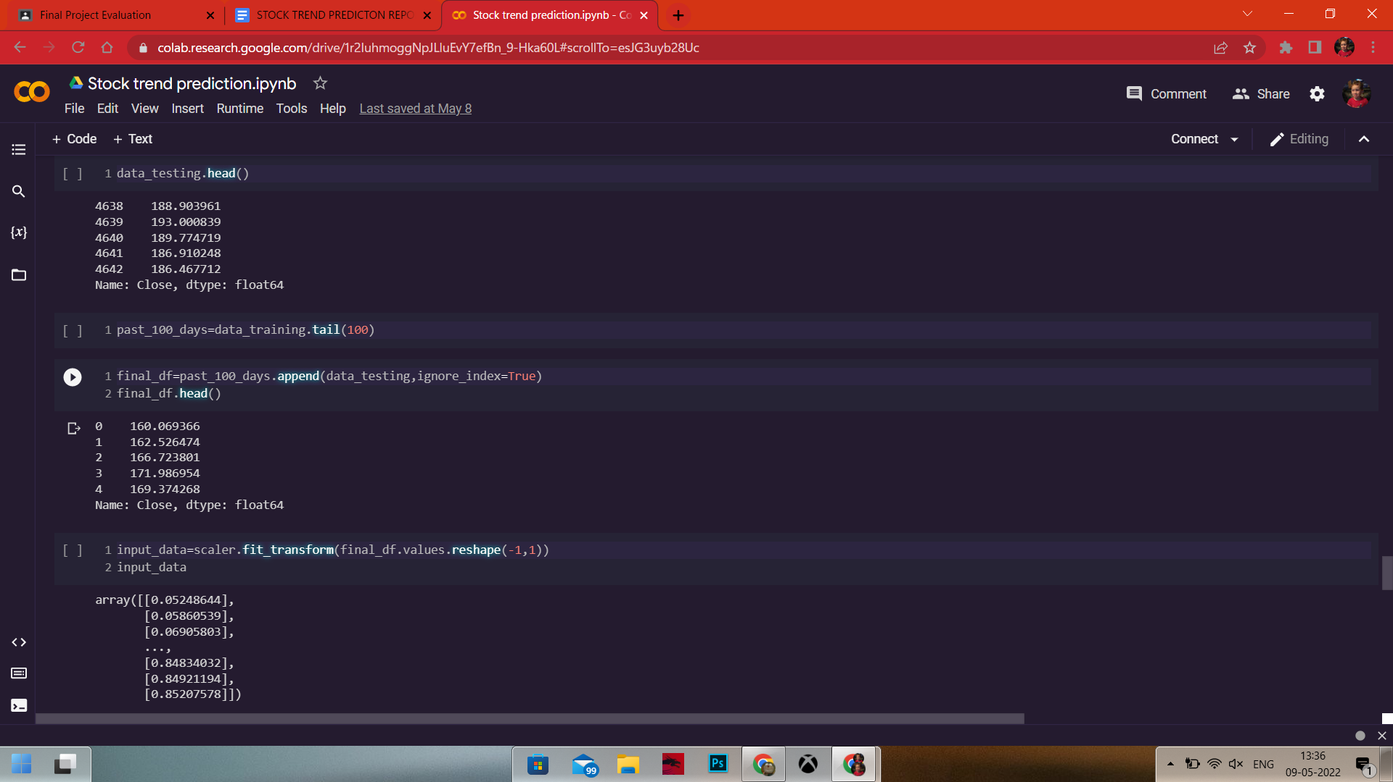

Then the data has been reshaped into a numpy array using the reshape function after which the value of y_predicted has been calculated.

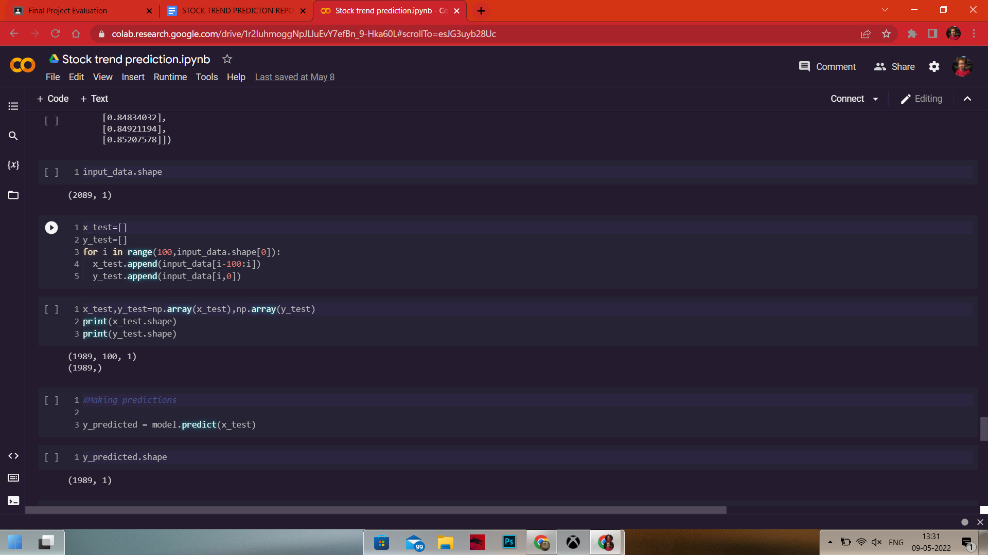

At the end we have displayed a graph showing the comparison of the original trend of a stock to the predicted trend of a stock.

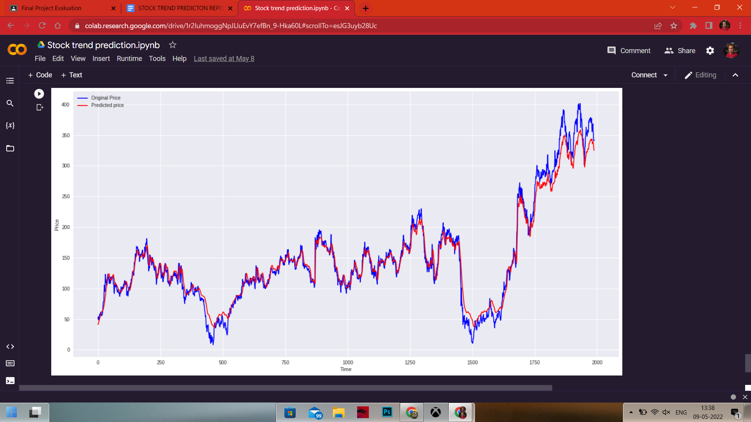

In the end we have created a web app using the streamlit application.

**CONCLUSION:**

We can see the Prediction, analysis and Visualisation of any stock using Yahoo Finance through applying deep learning algorithms such as Regression, LSTM, Dense, Drop out and sequential.

Same way we can use and stock database directly to apply this algorithm it will give us the correct prediction.

This successfully runs on cloud platforms as well.